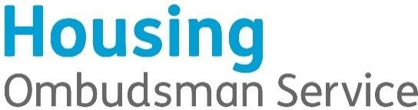

EQUALITY & DIVERSITY MONITORING

The Housing Ombudsman Service is opposed to unfair or unlawful discrimination. You do not have to fill in this form but doing so will help us to see if we are achieving our aim of treating all our colleagues equally and to find ways of doing better.

This is completely confidential and for HR purposes only
Sex Man * Woman * Intersex * Non-binary * Prefer not to say * If you prefer to use your own term, please specify here …………………….

Are you married or in a civil partnership? Yes * No * Prefer not to say *

Age 16-24 * 25-29 * 30-34 * 35-39 * 40-44 * 45-49 * 50-54 * 55-59 * 60-64 * 65+ * Prefer not to say *

What is your race?
Refers to your colour, nationality, ethnic or national origins. It is about the group to which you perceive you belong. Please tick the appropriate box

White
English * Welsh * Scottish * Northern Irish * Irish *
British * Gypsy or Irish Traveller * Prefer not to say *
Any other white background, please write in:

Mixed/multiple ethnic groups
White and Black Caribbean * White and Black African * White and Asian * Prefer not to say *
Any other mixed background, please write in:

Asian/Asian British
Indian * Pakistani * Bangladeshi * Chinese * Prefer not to say *
Any other Asian background, please write in:

Black/ African/ Caribbean/ Black British
African * Caribbean * Prefer not to say *
Any other Black/African/Caribbean background, please write in:

Other ethnic group
Arab * Prefer not to say *
Any other ethnic group, please write in:

Do you consider yourself to have a disability?
Yes * No * Prefer not to say *

What is the effect or impact of your disability on your ability to give your best at work?
Please write in here:

The information in this form is for monitoring purposes only. If you believe you need a ‘reasonable adjustment’, then please discuss this with your manager, or the manager running the recruitment process if you are a job applicant.

What is your sexual orientation?
Heterosexual * Gay * Lesbian * Bisexual *
Prefer not to say *
If you prefer to use your own term, please write in:

What is your religion or belief?
No religion or belief * Buddhist * Christian * Hindu * Jewish *
Muslim * Sikh * Prefer not to say *
If other religion or belief, please write in:

What is your current working pattern?
Full-time * Part-time * Prefer not to say *

What is your flexible working arrangement?
None * Flexi-time * Staggered hours * Term-time hours *
Annualised hours * Job-share * Flexible shifts * Compressed hours *
Homeworking * Prefer not to say *
If other, please write in:

Do you have caring responsibilities? If yes, please tick all that apply
None * Primary carer of a child/children (under 18) *
Primary carer of disabled child/children *
Primary carer of disabled adult (18 and over) *
Primary carer of older person *
Secondary carer (another person carries out the main caring role) *
Prefer not to say *

